

**THE UNIVERSITY OF TEXAS AT ARLINGTON, TEXAS  
DEPARTMENT OF ELECTRICAL ENGINEERING**

**EE 5356**

**DIGITAL IMAGE PROCESSING**

**PROJECT # 4**

**by**

**SOUTRIK MAITI**

**1001569883**

**Presented to**

**Dr. K.R.RAO**

**Mar 1, 2019**

**Color Transformation 3A**

MATLAB Code:

%% Read the image

img_origin = double(imread('flowers.bmp'));

%% The R,G,B components are as follows:

R_img = img_origin(:,:,1);

G_img = img_origin(:,:,2);

B_img = img_origin(:,:,3);

%% Reconstruction of image from the components:

I(:,:,1) = R_img;

I(:,:,2) = G_img;

I(:,:,3) = B_img;

%% Display original Image

figure(1)

imshow(uint8(img_origin));

title('Original Image (500*362)');

%% Display the RGB components of the image

figure(2)

subplot(4,3,1)

imshow(uint8(R_img));

title('Red Channel');

subplot(4,3,2)

imshow(uint8(G_img));

title('Green Channel');

subplot(4,3,3)

imshow(uint8(B_img));

title('Blue Channel');

%% Color Transform

Y = R_img * 0.257 + G_img * 0.504 + B_img * 0.098 + 16;

Cb = R_img * (-0.148) + G_img * (-0.291) + B_img * 0.439 + 128;

Cr = R_img * 0.439 + G_img * (-0.368) + B_img * (-0.071) + 128;

%% Display Y,Cb,Cr components of the image

subplot(4,3,4)

imshow(uint8(Y))

title('Y');

subplot(4,3,5)

imshow(uint8(Cb))

title('Cb');

subplot(4,3,6)

imshow(uint8(Cr))

title('Cr');

%% Decimation filters for Y, Cb and Cr

Y_decim = [-29 0 88 138 88 0 -29] / 256;

C_decim = [1 3 3 1] / 8;

%% Performing decimation

Cr_down = downsample(Cr',2)';

Cb_down = downsample(Cb',2)';

Y_filter = imfilter(Y, Y_decim, 'circular', 'conv');

Y_down = downsample(downsample(Y_filter,2)',2)';

Cr_Int = imfilter(Cr_down, C_decim, 'circular', 'conv');

Cr_down = downsample(downsample(Cr_Int,2)',2)';

Cb_filter = imfilter(Cb_down, C_decim, 'circular', 'conv');

Cb_down = downsample(downsample(Cb_filter,2)',2)';

%% Displaying the decimated values of Y,Cb,Cr

subplot(4,3,7)

imshow(uint8(Y_down))

title('Y Decimated');

subplot(4,3,8)

imshow(uint8(Cb_down))

title('Cb Decimated');

subplot(4,3,9)

imshow(uint8(Cr_down))

title('Cr Decimated');

%% Interpolation filter for Y,Cb,Cr

Y_Interpol = [-12 0 140 256 140 0 -12] / 256;

C_Interpol = [ 1 0 3 8 3 0 1] / 8;

%% Performing decimation

Y_Up = upsample(upsample(Y_down,2)',2)';

Y_Up_filter = imfilter(Y_Up,Y_Interpol,'circular','conv');

Y_Int = imfilter(Y_Up_filter,Y_Interpol','circular','conv');

Cb_Up = upsample(upsample(Cb_down,2)',2)';

Cb_Up_filter = imfilter(Cb_Up,C_Interpol','circular','conv');

Cb_Int = imfilter(Cb_Up_filter,C_Interpol,'circular','conv');

Cb_Up_Up = upsample(Cb_Int',2)';

c1 = size(Cb_Up_Up,2);

Cb_Up_Up(:,c1) = Cb_Up_Up(:,c1-1);

for cnt = 2:2:c1-1

Cb_Up_Up(:,cnt) = (Cb_Up_Up(:,cnt-1) + Cb_Up_Up(:,cnt+1))/2;

end

Cr_Up = upsample(upsample(Cr_down,2)',2)';

Cr_Up_filter = imfilter(Cr_Up,C_Interpol','circular','conv');

Cr_Int = imfilter(Cr_Up_filter,C_Interpol,'circular','conv');

Cr_Up_Up = upsample(Cr_Int',2)';

c2 = size(Cr_Up_Up,2);

Cr_Up_Up(:,c2) = Cr_Up_Up(:,c2-1);

for cnt = 2:2:c2-1

Cr_Up_Up(:,cnt) = (Cr_Up_Up(:,cnt-1) + Cr_Up_Up(:,cnt+1))/2;

end

%% Displaying the decimation values

subplot(4,3,10)

imshow(uint8(Y_Int))

title('Y Interpolated');

subplot(4,3,11)

imshow(uint8(Cb_Up_Up))

title('Cb Interpolated');

subplot(4,3,12)

imshow(uint8(Cr_Up_Up))

title('Cr Interpolated');

saveas(gca,'Components','jpg');

%% Reconstructing R,G,B from interpolated Y,Cr,Cb

r_recon = 1.164*(Y_Int-16) + 1.596*(Cr_Up_Up-128);

g_recon = 1.164*(Y_Int-16) - 0.813*(Cr_Up_Up - 128) - 0.392 * (Cb_Up_Up-128);

b_recon = 1.164*(Y_Int-16) + 2.017*(Cb_Up_Up-128);

recon_R = zeros(362,500,3);

recon_G = zeros(362,500,3);

recon_B = zeros(362,500,3);

recon_R(:,:,1) = r_recon;

recon_G(:,:,2) = g_recon;

recon_B (:,:,3) = b_recon;

recon_img = zeros(362,500,3);

recon_img(:,:,1)=recon_R(:,:,1);

recon_img(:,:,2)=recon_G(:,:,2);

recon_img(:,:,3)=recon_B(:,:,3);

%% Displaying reconstructed R,G,B components

figure(3);

subplot(1,3,1);

imshow(uint8(recon_R));

title('R Reconstructed');

subplot(1,3,2);

imshow(uint8(recon_G));

title('G Reconstructed');

subplot(1,3,3);

imshow(uint8(recon_B));

title('B Reconstructed');

saveas(gca,'recon_comp','jpg');

%% Display reconstructed image

figure(4);

imshow(uint8(recon_img));

title('Reconstructed Image(500*362)');

saveas(gca,'recon_img','jpg');

**Results:**

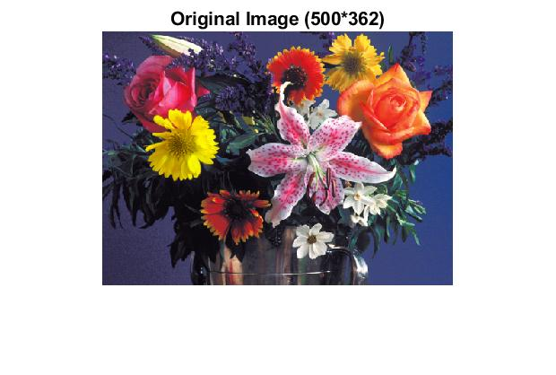

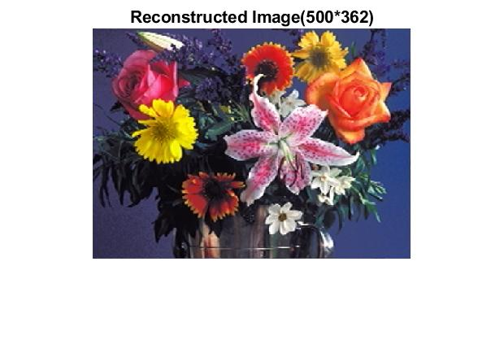

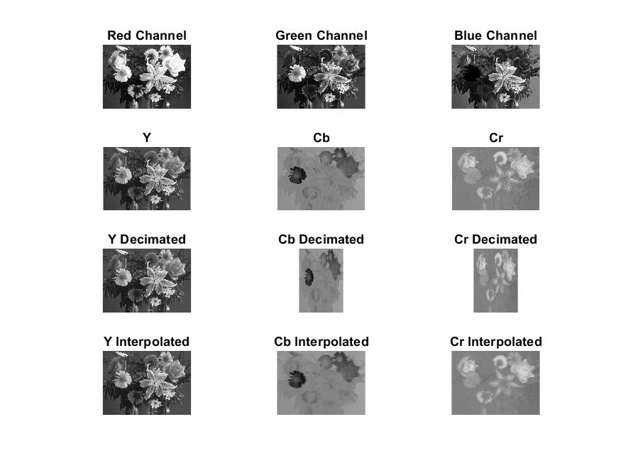

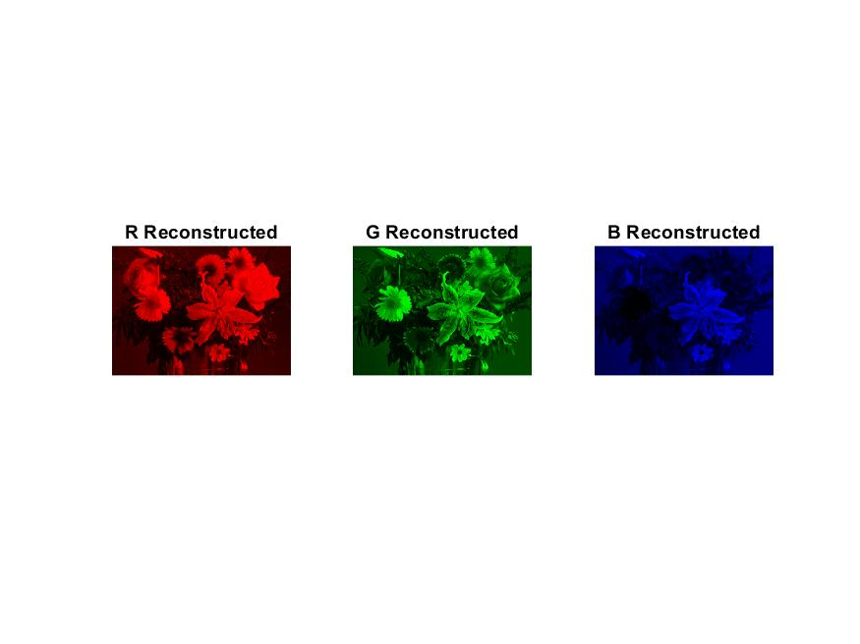

**Procedure:**

* The image is decomposed into its RGB components.
* It is then converted to YCbCr components with application of the conversion formula.
* The YCbCr components are down sampled in the ratio 4:2:2.
* To this down sampled YCbCr components, the process of Decimation filtering is performed.
* To bring back the components to the original resolution a process called up sampling is performed.
* The up sampled image is further done by Interpolation filtering.
* YCbCr domain is obtained after Conversion from RGB domain.
* From RGB domain, the reconstructed image is obtained.